**BIG DATA ANALYSIS ON AMAZON APPLICATION**

**ABSTRACT**

Big data refers to vast, complex datasets characterized by volume, variety, and velocity, which traditional data processing tools cannot handle. Amazon, founded by Jeff Bezos in 1994, is a global leader in e-commerce and technology, renowned for its innovative approaches and customer-centric philosophy. The company leverages big data to optimize operations, enhance customer experiences, and drive innovation. Through Amazon Web Services (AWS), Amazon employs advanced technologies to manage its big data needs, including scalable storage (Amazon S3, DynamoDB, RDS), data processing (Amazon EMR, AWS Lambda), real-time data streaming (Amazon Kinesis), data warehousing and analytics (Amazon Redshift, AWS Glue), machine learning and AI (Amazon SageMaker), and business intelligence (Amazon QuickSight). These tools enable Amazon to efficiently process, analyze, and derive insights from massive datasets, maintaining its competitive edge in the market and offering scalable solutions for other businesses.

**WHAT IS BIG DATA?**

The term "big data" describes extraordinarily massive and intricate datasets that are more sophisticated than what can be handled by conventional data processing software. Big data is characterized by the "three V's": volume, variety, and velocity. It comprises enormous volumes of data, ranging from terabytes to petabytes, gathered from a range of sources, including social media, structured databases, unstructured text, photos, and videos. Because of the speed at which this data is created, processing and analysis must happen quickly. Big data also involves value, which emphasizes the important insights and advantages that may be obtained from its analysis, and veracity, which emphasizes the necessity of data quality and trustworthiness. Advanced technologies and processes are necessary for the efficient administration and usage of these traits, which provide firms with strategic benefits and actionable insights.

Furthermore, big data is essential for promoting innovation in a variety of sectors. It makes it possible to analyze enormous volumes of patient data in the healthcare industry to enhance diagnosis and create individualized treatment programs. Big data in finance aids in risk management and the detection of fraudulent activity. It makes it possible for marketers to focus advertisements and identify trends in customer behavior. While the energy sector uses big data for predictive maintenance and smart grid management, the transportation sector employs it for route optimization and fleet operations management. The capacity to successfully use big data becomes a critical competitive advantage as businesses continue to generate and collect data at previously unheard-of rates. This can result in improved operational efficiencies, new revenue streams, and better informed decision-making.

**AMAZON**

Amazon, the world's largest technology and e-commerce company, was established in 1994 by Jeff Bezos. Renowned for its extensive online marketplace, innovative products, and customer-focused approach, Amazon began as a modest online bookstore. It has since diversified its offerings to include a wide range of products and services such as electronics, clothing, and cloud computing through Amazon Web Services (AWS). Known for its relentless innovation, Amazon has transformed the retail landscape with initiatives like one-day shipping, cashier-less stores, and personalized recommendations, solidifying its position as a leader in the online marketplace.

Big data is being used by Amazon, the world's largest online retailer, to transform business processes and improve consumer experiences. Amazon uses vast amounts of data from various sources to construct sophisticated algorithms for efficient inventory management, dynamic pricing, and customized suggestions. By offering personalized shopping experiences, this data-driven approach increases consumer satisfaction while ensuring competitive price and timely delivery. Amazon uses big data for fraud detection, trend analysis, and logistics optimization—all of which contribute to the company's continued dominance in the retail industry. The company further exemplifies its commitment to innovation and technological advancement by allowing other businesses to use Amazon Web Services (AWS) to harness big data.

**HOW AMAZON DEAL WITH BIG DATA?**

To manage its own big data requirements, Amazon leverages AWS (Amazon Web Services). Amazon receives the infrastructure and resources it needs from AWS to handle, process, and analyze the enormous volumes of data produced by its many services and activities. It's an extensive and popular cloud computing platform that Amazon offers. Computing power, storage, databases, analytics, networking, machine learning, artificial intelligence (AI), Internet of Things (IoT), security, and other cloud-based services are all provided by AWS. Businesses and organizations may acquire computing resources and expand their applications as needed with these pay-as-you-go services, which eliminate the need for an upfront investment in physical infrastructure

AWS is a well-liked option for startups, big businesses, governments, and people looking to use cloud computing for a variety of uses, from basic web hosting to sophisticated data analytics and machine learning applications, because of its dependability, scalability, and flexibility..

**TECHNOLOGIES USED BY AWS FOR DEALING WITH BIG DATA**

**Data Storage:**

Data storage options include:

• Scalable object storage for massive volumes of data via Amazon S3 (Simple Storage Service).

• Amazon DynamoDB: A NoSQL database service that is completely controlled.

• Relational databases for structured data are managed by Amazon RDS (Relational Database Service).

It's an extensive and popular cloud computing platform that Amazon offers. Computing power, storage, databases, analytics, networking, machine learning, artificial intelligence (AI), Internet of Things (IoT), security, and other cloud-based services are all provided by AWS. Businesses and organizations may acquire computing resources and expand their applications as needed with these pay-as-you-go services, which eliminate the need for an upfront investment in physical infrastructure. Because of its reputation for dependability, scalability, and flexibility, AWS is a preferred option for small and medium-sized businesses, government organizations, and private citizens wishing to use cloud computing for a range of purposes, from basic web hosting to sophisticated data analytics and machine learning applications.

**Data Processing:**

• Amazon EMR (Elastic MapReduce): Uses frameworks for distributed computing, such as Hadoop and Spark, to process massive datasets.

• AWS Lambda: Facilitates event-driven computing and serverless data processing.

Amazon processes massive data sets using distributed computing frameworks like Apache Hadoop and Apache Spark by using Amazon EMR (Elastic MapReduce). Serverless data processing with AWS Lambda makes event-driven computing jobs possible.

**Real-Time Data Streaming:**

* Amazon Kinesis: Manages real-time data streaming and processing, suitable for high-volume data like clickstreams.

Amazon employs Amazon Kinesis for real-time data streaming and processing, allowing them to handle large volumes of streaming data, such as clickstream data from their e-commerce platform.

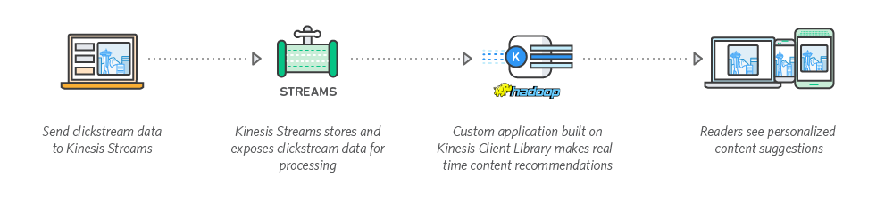

**Data Warehousing And Analytics:**

* Amazon Redshift:

One completely managed data warehouse for quick analytics and querying is Amazon Redshift.

• AWS Glue: Enables data preparation and loading for analysis using ETL operations.

Amazon performs sophisticated and quick queries on massive datasets using Amazon Redshift, a fully managed data warehouse service. ETL (extract, transform, load) procedures employ Amazon Glue to simplify the loading and preparation of data for analysis.

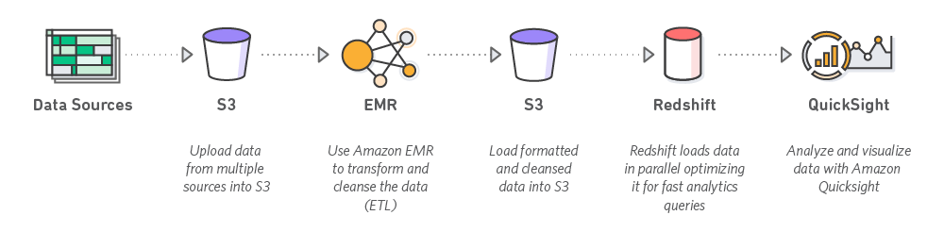

**Machine Leaning And AI:**

• Amazon SageMaker: A platform for large-scale machine learning model construction, training, and implementation.

Machine learning models are created, trained, and deployed at scale by Amazon using Amazon SageMaker. This aids in their predictive analytics-based service improvement and the extraction of useful information. Machine learning (ML) hub Amazon SageMaker JumpStart provides pre-trained models and pre-built solutions. You can access hundreds of foundation models (FMs) with it. With SageMaker JumpStart, an organization may centralize model artifacts, improve discoverability, and boost internal reuse by sharing notebooks and models through a private hub feature.

Using the Amazon SageMaker Python SDK, administrators may now create repositories for a subset of models customized for various teams, use cases, or license needs thanks to SageMaker JumpStart and its private hub functionality. Administrators have the ability to create numerous private hubs, each with a distinct list of models that are discoverable by various user groups.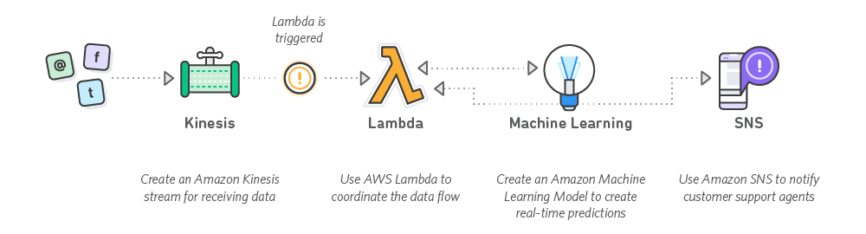

The following diagram shows an example architecture of SageMaker JumpStart with its public and private hub features. The diagram illustrates how SageMaker JumpStart provides access to different model repositories, with some users accessing the public SageMaker JumpStart hub and others using private curated hubs.

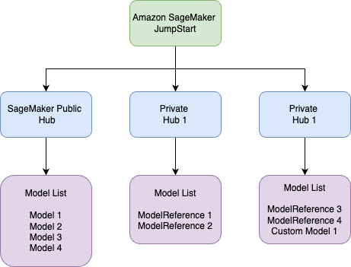

**Business Intelligence:**

* **Amazon QuickSight:** A business intelligence tool for creating interactive dashboards and visualizations.

Amazon QuickSight is used for business intelligence and data visualization, enabling Amazon to create interactive dashboards and reports for decision-making. The data is stored in Amazon S3, crawled by [AWS Glue](https://aws.amazon.com/glue/), tabled in [Amazon Athena](https://aws.amazon.com/athena/), and pulled by QuickSight through to our dashboards. It’s a seamless AWS ecosystem that removes a lot of work from our developers.

QuickSight has transformed the way Prospect operates. At the heart of this transformation is a significant shift from consultancy with a great deal of internal work to a more hands-on, real-time system clients can use themselves.

QuickSight has drastically reduced our build time. Its ability to pull from a shared data lake while preserving client data privacy and templated, configurable dashboards enabled us to scale faster and more cost-effectively.

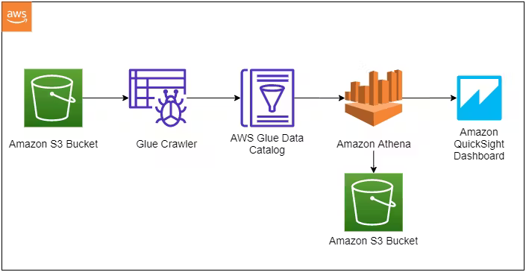

**Conclusion:**

In conclusion, Amazon's strategic utilization of big data through AWS showcases the transformative power of advanced data management technologies. By leveraging scalable storage solutions, sophisticated data processing frameworks, real-time data streaming capabilities, robust data warehousing, and cutting-edge machine learning and AI tools, Amazon not only enhances its operational efficiency and customer satisfaction but also drives continuous innovation. AWS provides the infrastructure and flexibility required to handle vast datasets, enabling Amazon to maintain its leadership in the e-commerce and technology sectors. This data-driven approach not only optimizes Amazon's internal processes but also empowers other businesses to harness the potential of big data, further emphasizing Amazon's role as a pioneer in leveraging technology for strategic advantages and market leadership.

**REFERENCES:**

* <https://aws.amazon.com/?nc2=h_lg>
* A case study on Amazon Big Data analysis: https://medium.com/codex/amazon-big-data-analysis-case-study-aa459a75156f
* A case study on Amazon AWS : https://aws.amazon.com/blogs/big-data/category/case-study/
* ChatGPT